**Project name:** Giveth

**Author name and contact info:**

Griff Green - griff@giveth.io | Discord: griff (, )#8888 | Telegram: **@griffgreen**

Yass - partnerships - [yass@giveth.io](mailto:yass@giveth.io) | Discord: Yass#3392 | Telegram: **@yass92**

I understand that I will be required to provide additional KYC information to the Optimism Foundation to receive this grant: **Yes**

**L2 recipient address:**

**Which Voting Cycle are you applying for?:** Voting cycle #..

**Grant category:** Governance Fund (Phase 1)

**Is this proposal applicable to a specific committee?** Not really… but if any the Tooling committee

**Project description (please explain how your project works):**

Giveth is incredibly aligned with Optimism in using web3 to evolve our coordination around Public Goods! Our community is focused on Building the Future of Giving using blockchain technology. Our intention is to support and reward the funding of public goods by creating open, transparent and free access to the revolutionary funding opportunities available within the Ethereum ecosystem.

We would like to add our Donation Application (<https://giveth.io>) to the Optimism chain so that every project on Giveth can raise funds with Optimism. On our DApp, 100% of donations go directly to the project and Donors to verified projects are rewarded with GIVbacks. Making a project to raise funds with Giveth is simple and permissionless, however to be part of the GIVbacks program and reward your donors with GIV, projects have to submit an application for our verification team to review to ensure they are truly a Public Goods project.

The GIVeconomy is what really sets us apart from just being another donation application, below is a quick run-through of the major pieces of our ecosystem.

**GIV** - A transferable ERC-20 token that lies at the heart of the future of giving (native to Mainnet). (LAUNCHED ✅ )

**GIVbacks** - The entry point to the GIVeconomy. Donors to verified public goods projects, get GIV tokens in return. This flips the script on tax deductible donation, creating a decentralized and borderless way of incentivizing donations. (LAUNCHED ✅ )

**GIVgarden** - Giveth’s token holder DAO. GIV token holders are able to propose and vote on how to use the Giveth community treasury using Conviction Voting. (LAUNCHED ✅ )

**rGIV DAO -** The equivalent of other economy’s foundation, this is a unique reputation DAO, any contributor who has been actively participating in our community for over 3 months can join. This DAO mostly handles the day-to-day operations and stewards the GIVeconomy smart contracts. (LAUNCHED ✅ )

**GIVpower** - Donors can lock their GIV tokens for GIVpower and use them to boost/curate projects and public goods on the platform. Projects with more GIVpower are ranked higher and in turn, reward their donors with more GIVbacks. Locking is live, boosting is fully developed and being tested now, it should roll out in an upcoming release (LAUNCHING 🚧)

**GIVfi** - Latent donations on the platform can be used to generate a low-risk yield while waiting to be disbursed. This yield is split between buying GIV tokens on the open market and the projects themselves (via GIVsavings), enabling nonprofits to have a defi saving account . (PHASED ROLL OUT - 2023)

**GIVmatching** - Top-ranked public goods and for-good projects on the platform will have the opportunity to have their donations matched via a collectively funded matching pool. We are collecting funds for the matching pool at donation.eth and will work with the Grants 2.0 system when it comes out (Q2 2023).

**GURVES** - The holy grail of public goods funding. Giveth projects can evolve into DAOs with their own micro-economy collateralized by GIV in a Bonding Curve. This is still very much in the research phase in partnership with Commons Stack, but is the Giveth endgame, turning the donation platform into an investment platform. (TBA)

We also have NFT projects, several integrations, partnerships, and community projects in the pipeline.

**Project links:**

* Website: <https://giveth.io/>
* Twitter: <https://twitter.com/Givethio>
* Discord/Discourse/Community: [Giveth Discord](https://discord.gg/Nj9zM9Dq)
* Please include all other relevant links below:
  + Youtube: [The Biggest Web3 Opportunity That No One Is Talking About](https://www.youtube.com/watch?v=ADSOVkujrI4&ab_channel=ETHDenver)
  + Deck: [Giveth deck](https://drive.google.com/file/d/1I1JRDMwohyA0tKamRxmS5bnqorB1J-5h/view?usp=sharing)

**Additional team member info (please link):**

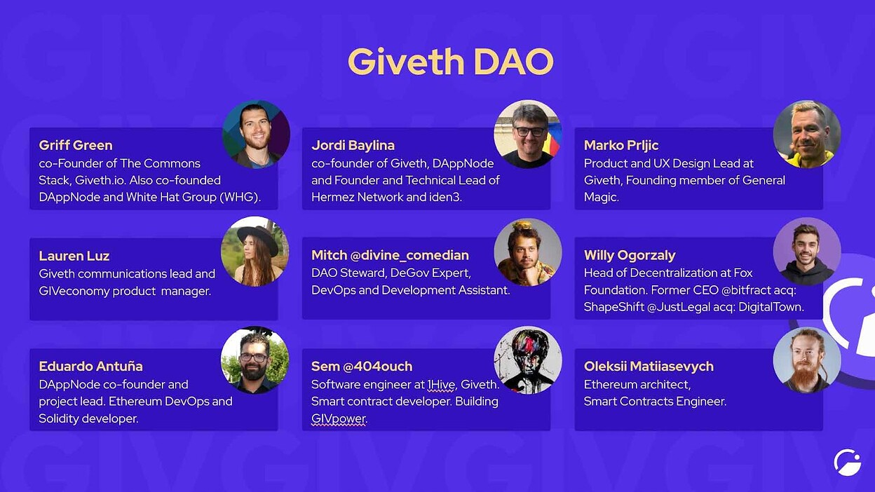

**Please link to any previous projects the team has meaningfully contributed to:**

TheDAO

White Hat Group

<https://aragon.org/>

<https://status.im/>

<https://iden3.io/>

<https://polygon.technology/solutions/polygon-hermez/>

<https://1hive.org/>

<https://www.gnosischain.com/>

<https://commonsstack.org/>

<https://tecommons.org/>

<https://www.brightid.org/>

<https://www.dappnode.io/>

<https://www.generalmagic.io/>

**Relevant usage metrics (TVL, transactions, volume, unique addresses, etc. Optimism metrics preferred; please link to public sources such as Dune Analytics, etc.):**

Since our launch at the end of December last year, we have helped raise over $1 million to verified projects on our platform, and over $500k in the last 3 months.  
  
We have some of the GIVeconomy stats here:  
<https://dune.com/metacrypto/giveconomy>

**Competitors, peers, or similar projects (please link):**

There is no competition in funding Public Goods!  
  
But at our core right now, we are a donation platform so some similar projects are:

Gitcoin.co   
Clr.fund  
The Giving Block  
  
We believe we complement these projects well as we are running our benefits for donating 24/7 as opposed to quarterly rounds.

**Is/will this project be open sourced?** ***Yes***

**Optimism native?:** ***No***

**Date of deployment/expected deployment on Optimism:**

2-3 months after this grant passes

**Ecosystem Value Proposition:**

* What is the problem statement this proposal hopes to solve for the Optimism ecosystem?

Optimism is sorely missing a donation platform. If someone wants to donate some of their profits to a for-good project, they must bridge to mainnet first. Giveth wants to change that!  
  
Not only can Giveth bring hundreds of already verified Public Goods projects to the Optimism network, we can also integrate and enhance the retroPGF system.  
  
We can enable projects on Giveth to raise funds on Optimism and any donation to verified projects on Optimism would get up to 75% of their donation back in GIV tokens through our GIVbacks program.   
  
GIVbacks is a Public Goods lego that could plug in nicely to the Retroactive Public Goods Funding program. Any funding to a verified project would receive GIVbacks. For example if a project (outside of the Optimism team) is providing an alternate RPC, they could qualify as a verified project and donations to support them would be eligible for GIVbacks.   
  
Learn more about GIVbacks here:   
  
<https://medium.com/giveth/what-if-giving-gave-back-using-web3-to-evolve-philanthropy-a8500b7636ce>

Giveth enables anyone working to produce public goods to raise funds with crypto, hopefully soon that will also be with funds on Optimism!

But this is just the beginning. Giveth hopes to help projects evolve past donations and sacrifice. Public goods are not just a feel-good, heartwarming act of kindness. They are a $25 Trillion global industry, and in our opinion the most overlooked web3 opportunity. We have the opportunity to disrupt this sector with web3 tooling & Giveth is positioned to lead the way. Check out this [awesome video](https://www.youtube.com/watch?v=DBGoX7DON54) from Devcon with Griff describing this opportunity at length, while also giving a shout out to OP and RPGF.

Given the crypto market outlook, user and nonprofit adoption growth, and innovations in fundraising, crypto has the potential to become the most powerful philanthropic force on the planet in the years ahead. In 2021, in just the US, the largest source of charitable giving came from individuals, who gave $326.87 billion, representing 67% of total giving ([National Philantropic trust](https://www.nptrust.org/philanthropic-resources/charitable-giving-statistics/)). <https://bit.ly/3C5KTgn>   
  
Crypto donations is witnessing incredible growth. The total annual volume of crypto donations grew by 1,558% or more than 16x from 2020 to 2021. Source: [theGivingBlock](https://thegivingblock.com/annual-report/ar21/#2022-crypto-philanthropy-outlook). Giveth can bring this growth to Optimism.

**Has your project previously applied for an OP grant?** If successful, please link to your previous grant proposal and provide a brief update on milestones achieved with the grant. If unsuccessful, and this is a resubmission, please specify how you have incorporated significant changes in accordance with feedback.

We were part of the retroactive public goods funding round before Optimism really launched but haven’t applied for a grant since.

**Number of OP tokens requested:** 400,000 $OP

**Did the project apply for or receive OP tokens through the Foundation Partner Fund?:** No

**If OP tokens were requested from the Foundation Partner Fund, what was the amount?:**0

**How much will your project match in co-incentives? (not required but recommended, when applicable):**  
100% of the incentives will come from our token, we will not use OP tokens for incentives.

**Proposal for token distribution:**

* How will the OP tokens be distributed? (please include % allocated to different initiatives such as user rewards/marketing/liquidity mining. Please also include a justification as to why each of these initiatives align with the problem statement this proposal is solving.)
* Over what period of time will the tokens be distributed for each initiative? Shorter timelines are preferable to longer timelines. Shorter timelines (on the order of weeks) allow teams to quickly demonstrate achievement of milestones, better facilitating additional grants via subsequent proposals.
* Please list the milestones/KPIs you expect to achieve for each initiative, considering how each relates to incentivizing sustainable usage and liquidity on Optimism. Please keep in mind that progress towards these milestones/KPIs should be trackable.
* Why will incentivized users and liquidity on Optimism remain after incentives dry up?

Our GIVbacks program is incredible, it is like the web3 replacement for tax deductible donations. No tax rebates, no government involvement at all. Instead, when people donate to verified projects on Giveth, they get up to 75% of their donation back in GIV tokens.   
  
Learn more about GIVbacks here:   
  
<https://medium.com/giveth/what-if-giving-gave-back-using-web3-to-evolve-philanthropy-a8500b7636ce>

We propose that we continue to use GIV tokens to reward Donors for their donations on Optimism, as we do on Mainnet and Gnosis Chain, and instead we use 100% of the OP tokens requested to create a 50/50 liquidity pool with GIV tokens on Sushiswap.

The intention is to create a win-win partnership where both projects get the benefit of extra liquidity on Mainnet, and we do not have to sell any OP. If people prefer OP rewards to GIV rewards, they can trade the GIV for OP.

🤯 Assuming prices stay stable, this distribution approach would create demand for OP instead of sell pressure. 🤯

**Please provide any additional information that will facilitate accountability:(smart contracts addresses relevant to the proposal, relevant organizational wallet addresses, etc.)**

Our giv.eth Gnosis Safe is on Optimism (0x4D9339dd97db55e3B9bCBE65dE39fF9c04d1C2cd) which can receive the OP, and will hold the LP token that is created.